POLITICAL JUGGERNAUTS: A QUENANTITATIVE ANALYSIS OF CANDIDATES IN THE 2019 LOK **SABHA ELECTIONS**

1. INTRODUCTION

1.1 Overview

Project Description:

The Lok Sabha is composed of representatives of people chosen by direct election on the basis of Universal Adult Suffrage. The Constitution of India allows for a maximum of 550 members in the House, with 530 members representing the States and 20 representing the Union Territories. The 17th Lok Sabha was formed by the members elected in the 2019 Indian general election. Elections, all across India, were conducted in seven phases from 11 April 2019 to 19 May 2019 by the Election Commission of India. The Bharatiya Janata Party received 37.36% of the vote, the highest vote share by a political party since the 1989 general election, and won 303 seats, further increasing its substantial majority. In addition, the BJP-led National Democratic Alliance (NDA) won 353 seats.

**1.2 Purpose**

(The use of the Project):

The purpose of A quantitative analysis would involve collecting data on these factors, conducting statistical tests, and drawing conclusions based on the evidence. Such research can provide valuable insights into the role of political juggernauts in the democratic process.

(What can be achieved using this):

In summary, the document "Political Juggernauts: A Quantitative Analysis of Candidates in the 2019 Lok Sabha Elections" can serve as a valuable resource for a wide range of purposes, from academic research to political strategy and public awareness. Its utility would depend on the specific insights and data it provides regarding the 2019 Lok Sabha elections.

**2 2. Problem Definition & Design Thinking 2.1 Empathy Map**

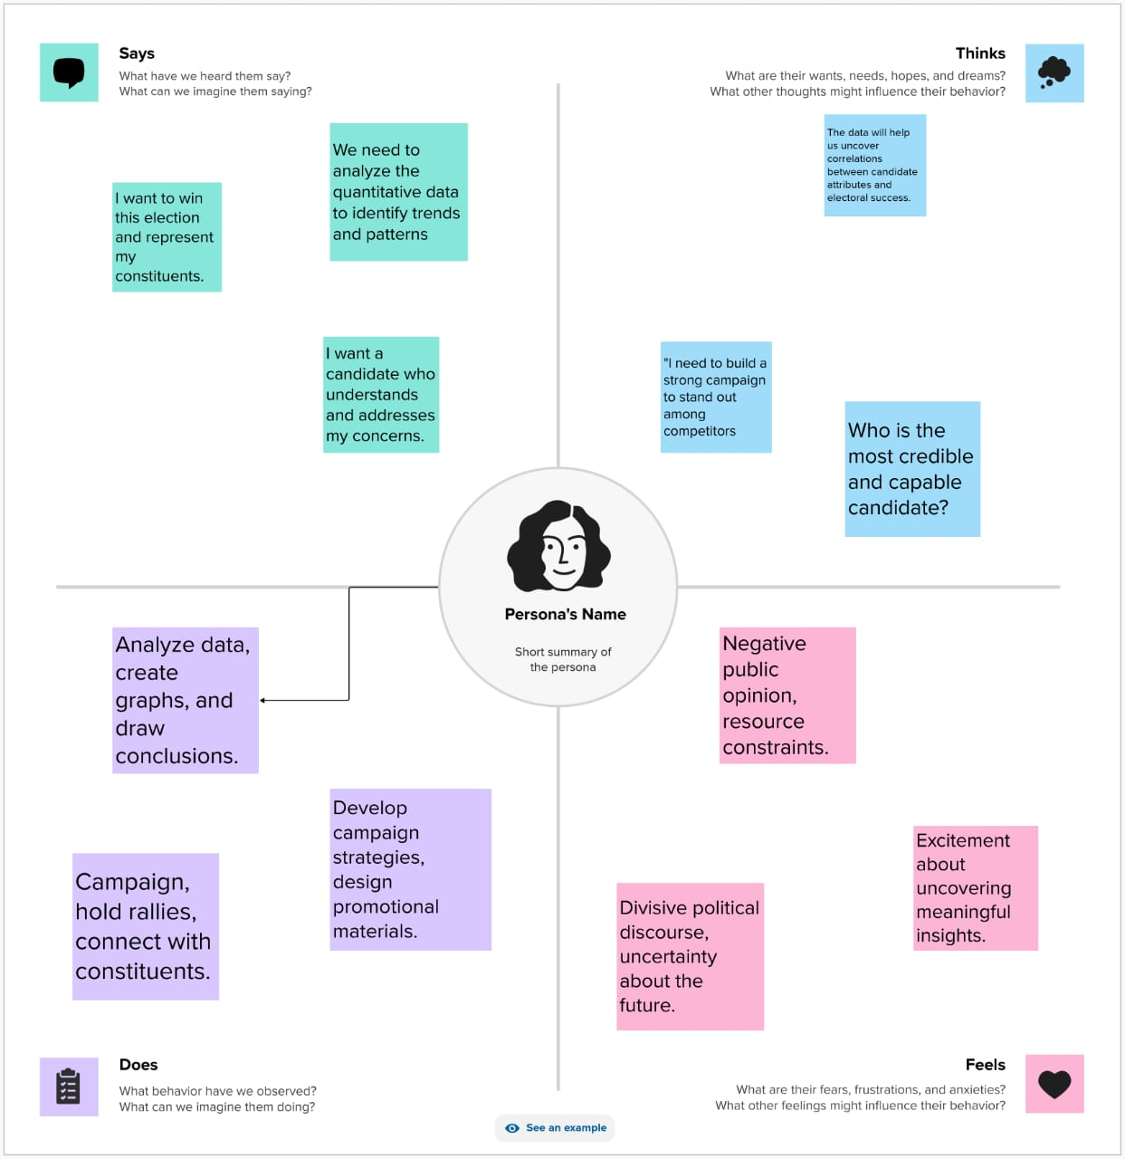

**2.2 Ideation & Brainstorming map :**

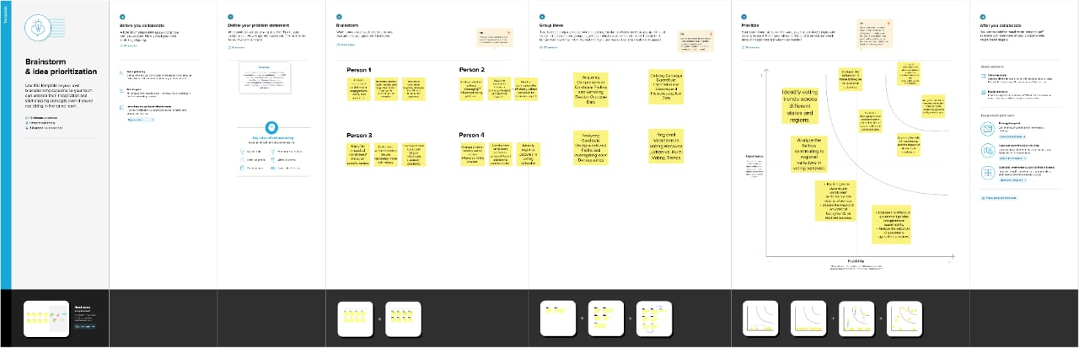

**3. RESULT 3.1Final findings (Output) of the project along with screenshots.**

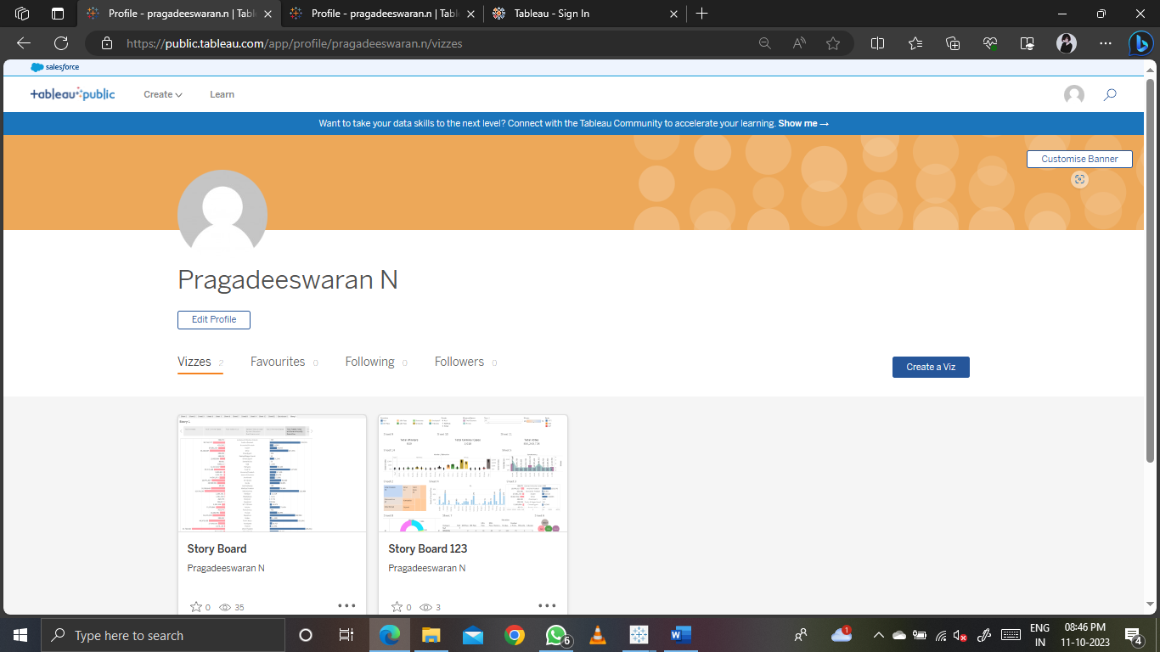

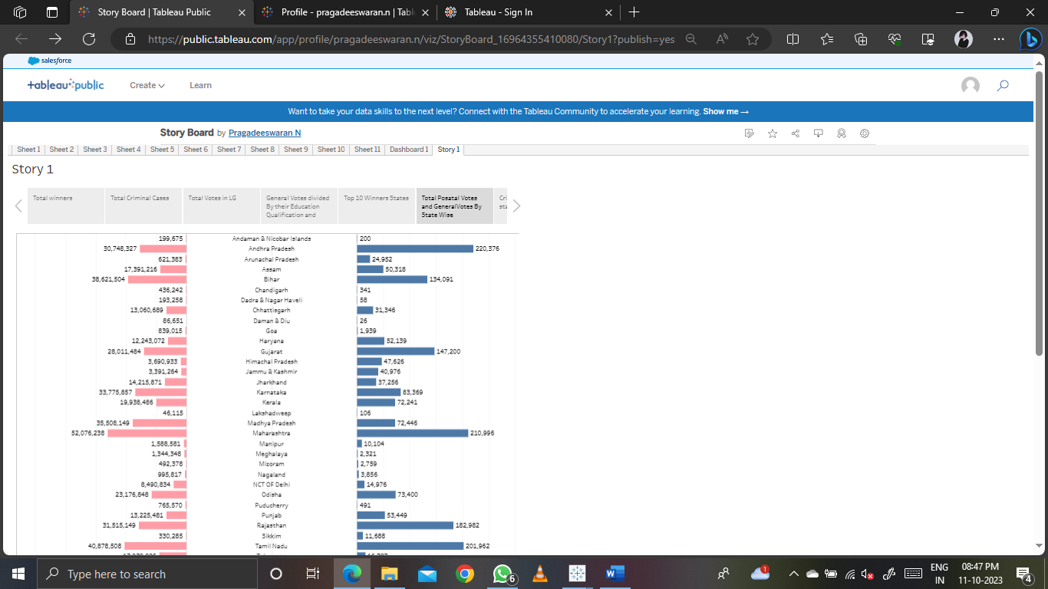

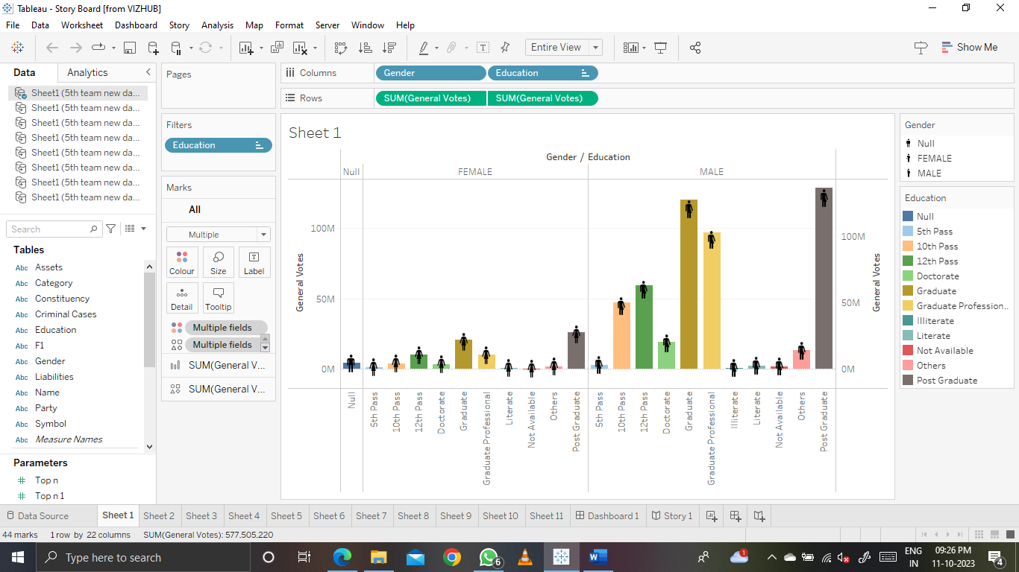

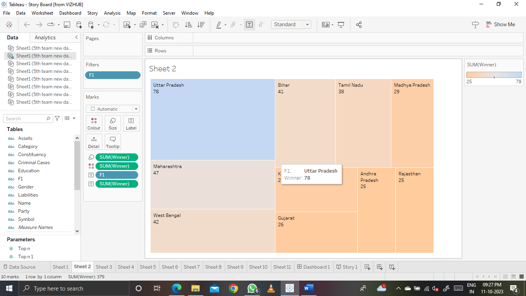

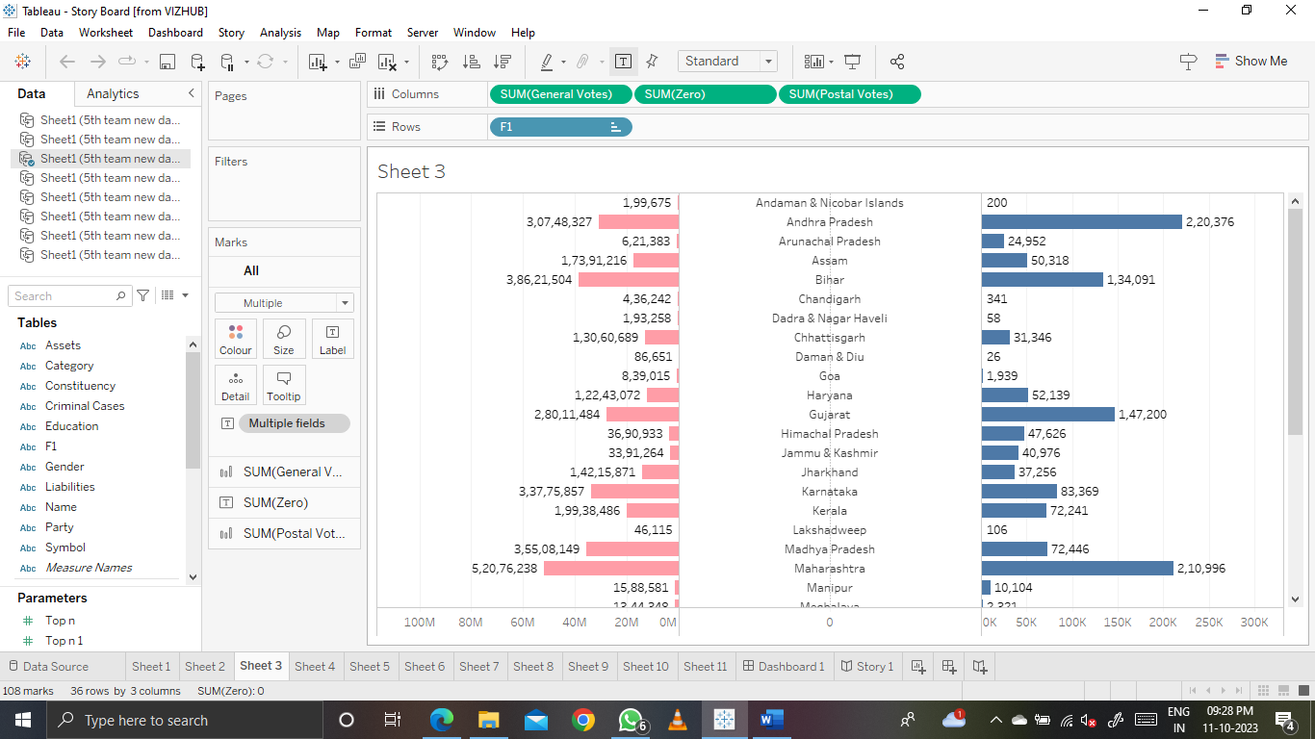

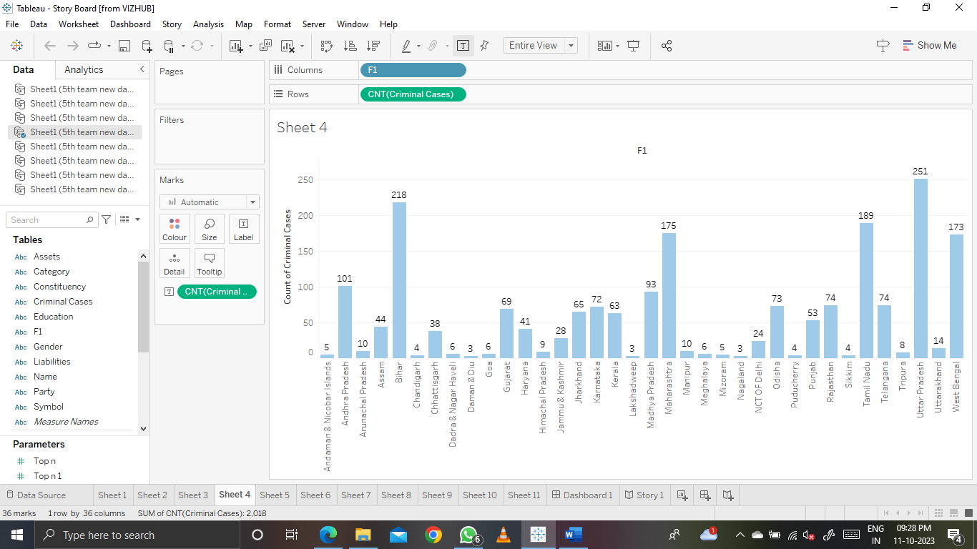

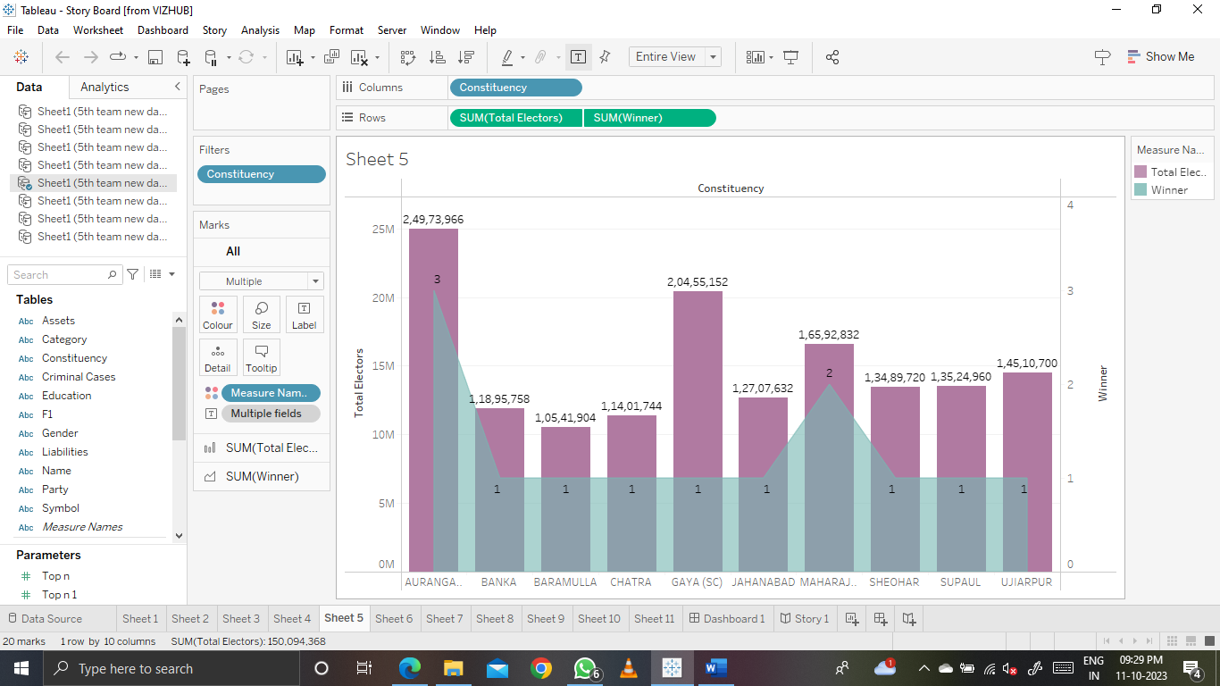

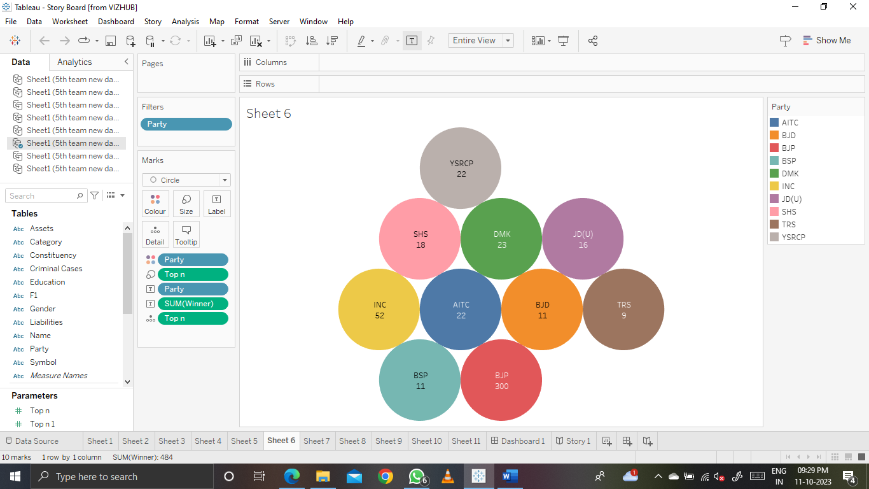

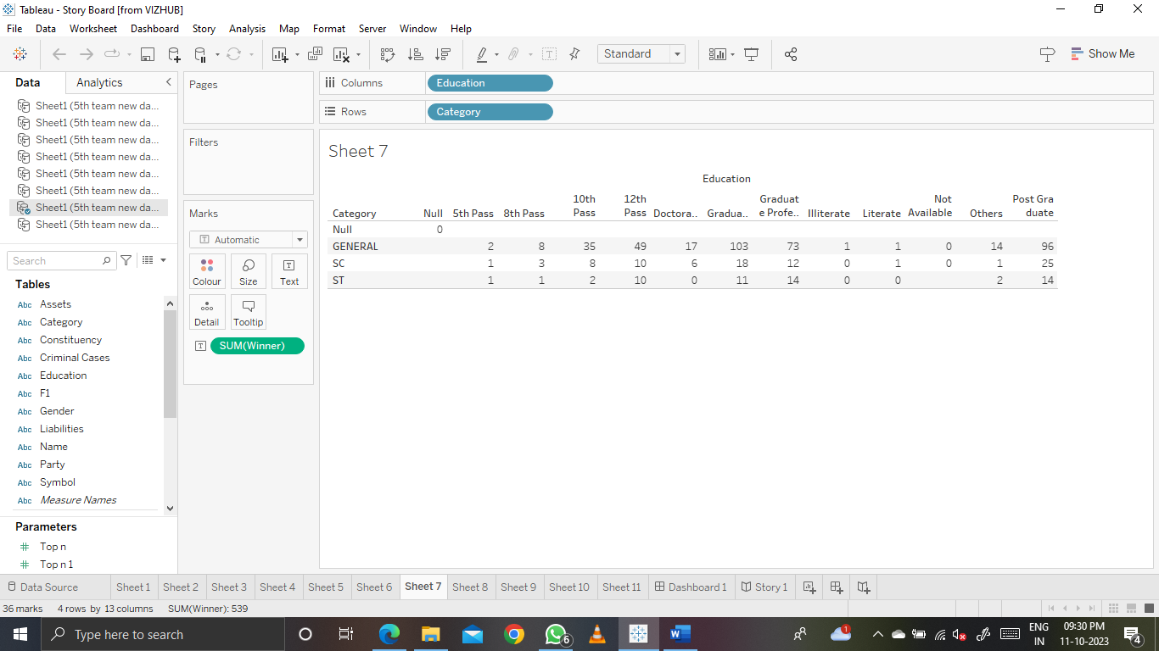

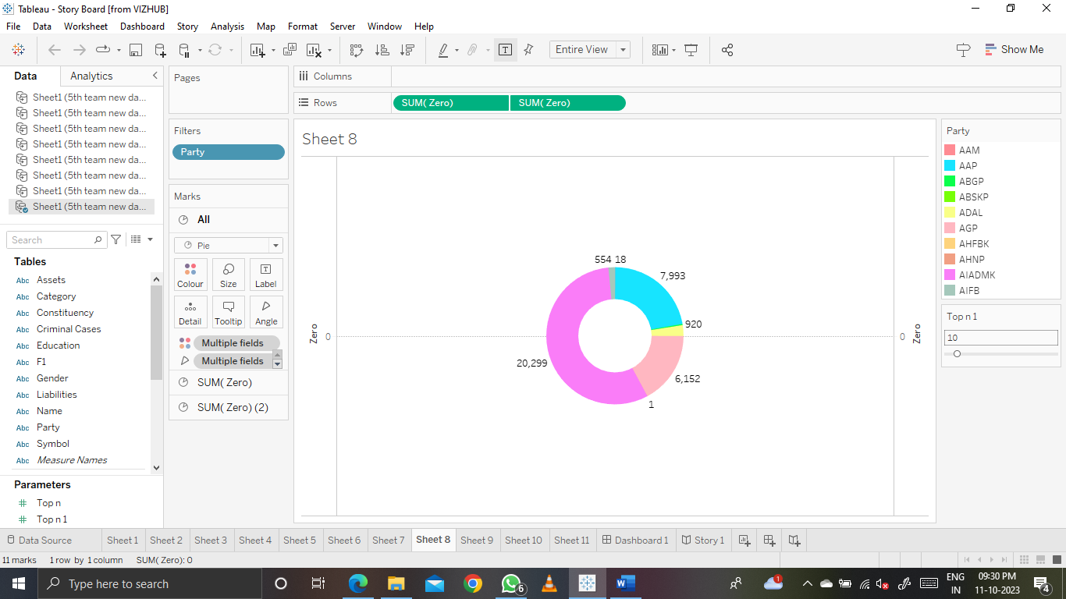

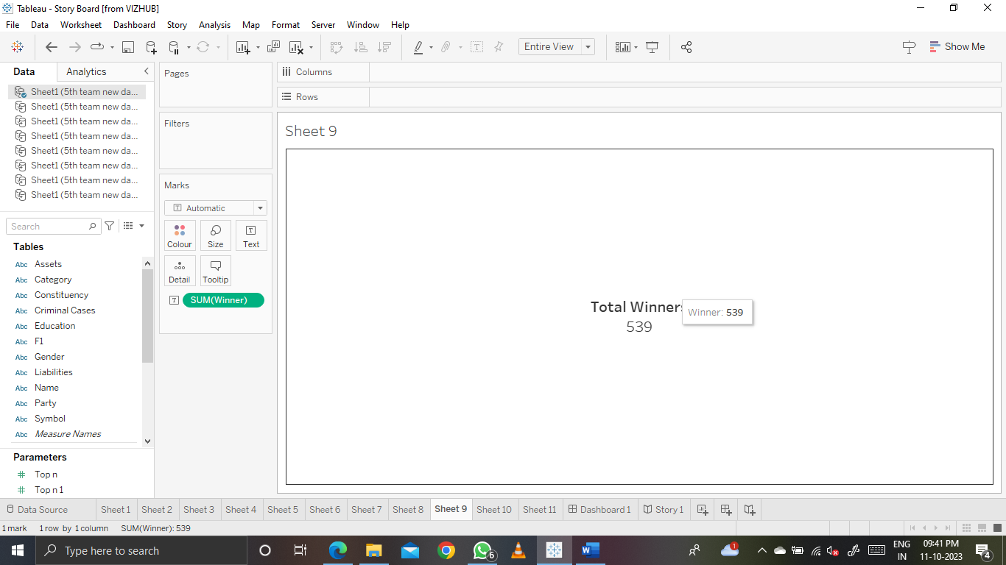

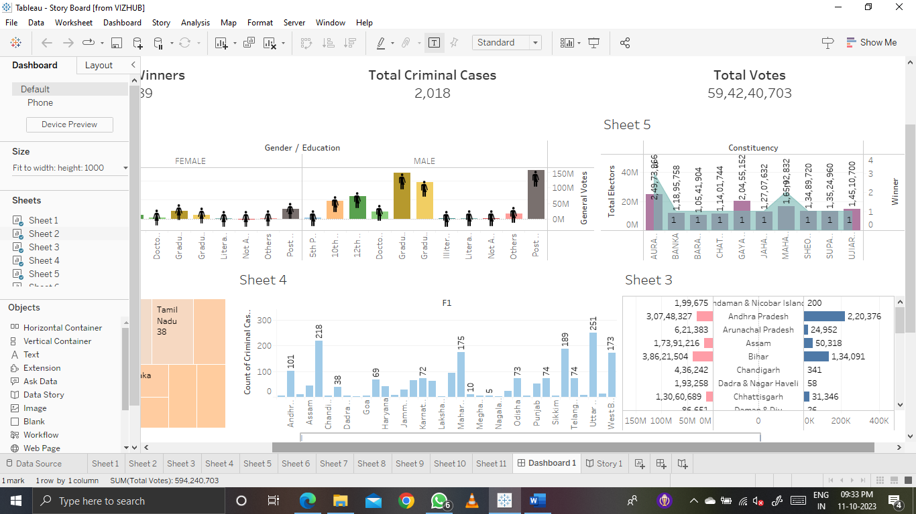

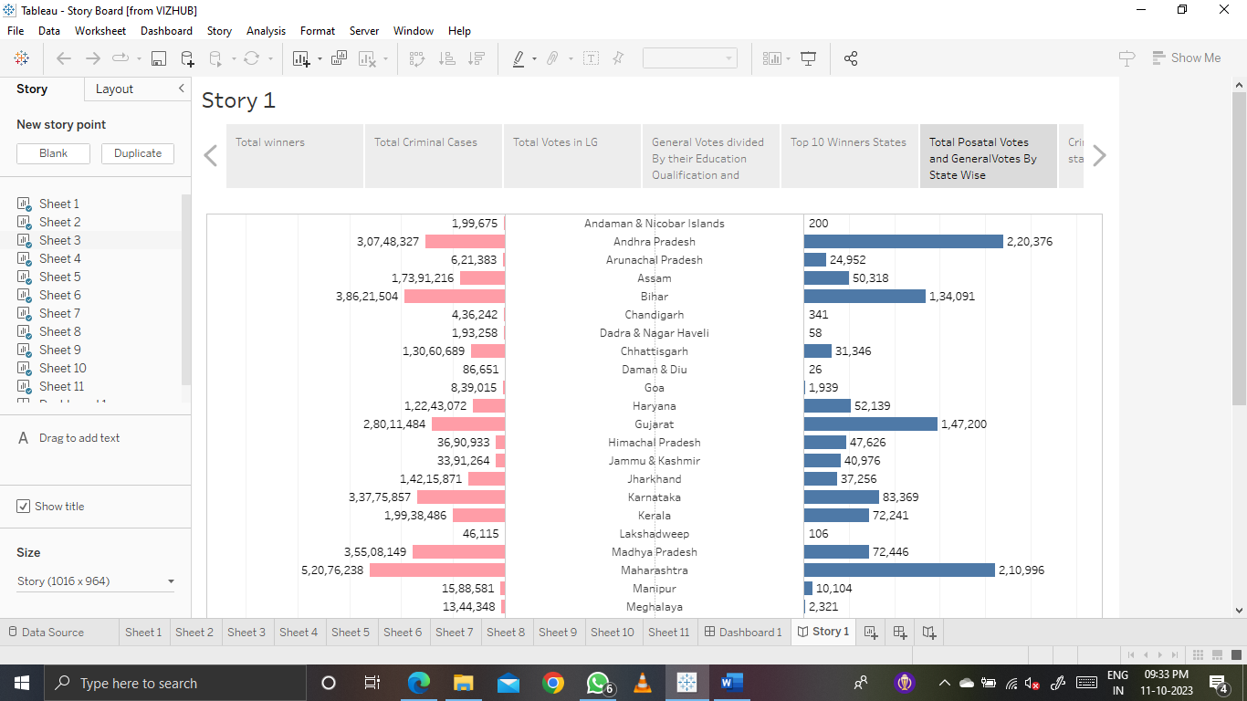

**13 4. Advantages &Disadvantages 4.1Advantages**

* The analyses used to determine vote percentage in various states. So in India, people are much aware of politics.
* Identify the number of female candidates is maximum or the number of male candidates is maximum in election.
* We could get the knowledge about the no. of votes in different states.
* We can know about the criminal cases of the candidates of different cases of the candidates of different age group.
* the date utilized to calculate the no of SC, St and GENERAL candidates in the Lok Sabha election 2019.
* **4.2 Disadvantages:**
* The data updating about our nation people is more complicated due to the population, migration and errors made by data collector.
* Frequent elections prevent transfer of power to a single entity to a momentary popularity surge that could help capture both the state and centre rue through simultaneous elections.
* Lacking of simultaneous elections with proper necessary reforms.
* The continuous cycle of elections puts stress on the exchequer, the contesting candidates, financers and the party especially the smaller ones as elections are becoming extremely expensive.
* Local and national issues may get mixed up and distort priorities

**5.Application :**

* Using the data analyse, counting the total number of allocation of candidates for different parties in different constituencies in India.
* Calculating the criminal case candidates in different parties. We can aware of criminal cases of the different parties.
* The analysis identified the candidate’s educational qualifications that are used to aware of their previous criminal background with their educational qualification.

**6.Conclusion :**

1. From this analysis, we have found that Indians are very much aware of the voting system and political parties. The vote percentage in very good in West Bengal, Maharashtra, Kerala, Manipur, etc.
2. The BJP candidates have participated more than the other parties in Lok sabha 2019.
3. The number of female candidates is very less than the number of male candidates.
4. It is transparent that the total number of votes in Utter Pradesh, Maharashtra, and west Bengal are very much higher than the remaining states in India and Utter Pradesh holds first place in the toral number of votes.

**7.Futurescope:**

Analyse the study to prove that local parties would suffer and regional issues would get lost as is feared by various regional parties.

**8.Appendix:**

**Dashboard 1 link :**

**https://public.tableau.com/views/StoryBoard_16964355410080/Dashboard1?:language=en-GB&:display_count=n&:origin=viz_share_link**

**Storyboard link :**

[**https://public.tableau.com/views/StoryBoard_16964355410080/Story1?:language=en-GB&:display_count=n&:origin=viz_share_link**](https://public.tableau.com/views/StoryBoard_16964355410080/Story1?:language=en-GB&:display_count=n&:origin=viz_share_link)

**Google Drive video link :**

[**https://drive.google.com/file/d/1qMgUwBnKDMC-O6WpdYgd2dXeowi9yZZm/view?usp=drive_link**](%20https:/drive.google.com/file/d/1qMgUwBnKDMC-O6WpdYgd2dXeowi9yZZm/view?usp=drive_link)